**ISG Security Awareness Mandates FAQ**





Table of Contents

1. WHY IS SECURITY AWARENESS TRAINING important? 3

2. What are the types of security awareness courses offered? 3

3. How do i access the course? 4

3.1 Direct Links: 4

3.2 Procedure to Launch Course via Twingo 6

3.3 Direct Search on DEXT Homepage 8

4. i am unable to launch the course or course is freezing and i am unable to proceed further. what should i do? 10

5. How can i launch course on my phone? 11

6. How can i assign the course to the associates who report to me? 14

7. HOW CAN I DOWNLOAD COURSE COMPLETION CERTIFICATE? 15

8. hOW DO I GET COMPLETION STATUS FOR MY TEAM? 15

9. WHAT IS THE EMAIL DL FOR RAISING ISG SECURITY MANDATE QUERIES? 15

10. WHO SHOULD I CONTACT IF I HAVE ANY QUESTIONS ABOUT THE ISG INFORMATION SECURITY TRAINING COURSE? 15

11. WHAT IS THE FREQUENCY OF SECURITY AWARENESS TRAINING COURSES? 16

# WHY IS SECURITY AWARENESS TRAINING important?

Security awareness training is provided to educate associates about the important role they play in helping prevent information breaches. It provides education about the type of risks faced by the the businesses, how employees might interact with them or be targeted by them, and how their actions can have a positive or negative affect.

# What are the types of security awareness courses offered?

|  |  |  |
| --- | --- | --- |
| **Code** | **Name** | **Details** |
| SS1369 | Data Protection & Privacy (Multilingual – English and EUR Languages) | •       Data privacy •       Importance of data privacy  •       Different ways in which cyber criminals steal private  data  •       Restate the European Union’s General Data  Protection Regulation (GDPR)  •       Basic principles of data protection  •       Tech Mahindra’s data protection policy  •       Handling personal data in the right way  •       Restate the stages of an Incident Response  •       Quick tips to protect data |
| SS18449 | Securing Our Business (Multilingual – English and EUR Languages) | •       Importance of Security in Business  •       Impact of security breaches, customer concerns and  illustrate the vital role associates play in ensuring  safety of business. •       Understanding of adversaries and methods used by  them to launch cyber attacks •       How to Identify, detect and report a phishing email  and commonly used phishing methods. •       Ensuring Safe Work from Home Environment |
| SS1431 | How to Build Secure Applications using TechM’s Standard Tools and Guidelines | •       Principle and Practices of Secure Development •       Secure Software Development Frameworks/Tools |
| SS18503 | Secure Delivery Management | •       Enable Managers to get control over the security  posture of the project.  •       Orient Managers with the Security practices,  processes for secure service delivery. |
| SS18220 | BPO Domestic Awareness | •       Overview of Information Security and Data  Protection for BPS Domestic Associates.  (U1-U3 Band) |
| SS18668 | Secure our Business and Data Privacy Refresher | •       Annual refresher Course is applicable for associates  who have either completed one year with TechM or  have completed this course a year ago.  •       This course is re-assigned every year to all the  associates who have already completed it, so that they  can swiftly refresh their knowledge on information  security concepts on yearly basis. |

**HR Function Mandate:**

|  |  |  |
| --- | --- | --- |
| **Code** | **Name** | **Details** |
| SS21198 | HR Function - Data Privacy and Protection | •      Data Privacy and Protection Course for HR  Function. |
| SS21199 | HR Associate - Cyber War Game Incident Simulation | •      Data Privacy Incident response simulation for  HR Associates (U1-U3 Band) |
| SS21200 | HR Manager - Cyber War Game Incident Simulation | •      Data Privacy Incident response simulation for  HR Managers (U4, P1 Band) |
| SS21201 | HR Senior Leader - Cyber War Game Incident Simulation | •      Data Privacy Incident response simulation for HR  Senior Leaders (P2, E1, E2, Band) |

**RMG Function Mandate:**

|  |  |  |
| --- | --- | --- |
| **Code** | **Name** | **Details** |
| SS20822 | RMG Function - Data Privacy and Protection | •       Data Privacy and Protection Course for RMG  Function. |
| SS20818 | RMG Associate Cyber War Game Incident Simulation | •       Data Privacy Incident response simulation for RMG  Associates (U1-U3 Band) |
| SS20819 | RMG Manager Cyber War Game Incident Simulation | •       Data Privacy Incident response simulation for RMG  Managers (U4, P1 Band) |
| SS20820 | RMG Senior Leader - Cyber War Game Incident Simulation | •       Data Privacy Incident response simulation for RMG  Senior Leaders (P2, E1, E2, Band) |

# How do i access the course?

## Direct Links:

* SS1369 - Data Protection and Privacy

<https://techmahindra.sumtotal.host/Core/pillarRedirect?relyingParty=LM&url=core%2Factivitydetails%2FViewActivityDetails%3FActivityId%3D171358%26UserMode%3D0>

* SS18449 - Securing Our Business

<https://techmahindra.sumtotal.host/Core/pillarRedirect?relyingParty=LM&url=core%2Factivitydetails%2FViewActivityDetails%3FActivityId%3D208197%26UserMode%3D0>

* SS1431 - How to Build Secure Applications using TechM’s Standard Tools and Guidelines

<https://techmahindra.sumtotal.host/Core/pillarRedirect?relyingParty=LM&url=core%2Factivitydetails%2FViewActivityDetails%3FActivityId%3D173645%26UserMode%3D0>

* SS18503 - Secure Delivery Management Practitioner

<https://techmahindra.sumtotal.host/Core/pillarRedirect?relyingParty=LM&url=core%2Factivitydetails%2FViewActivityDetails%3FActivityId%3D214878%26UserMode%3D0>

* SS18220 - BPO Domestic Awareness <https://techmahindra.sumtotal.host/Core/pillarRedirect?relyingParty=LM&url=core%2Factivitydetails%2FViewActivityDetails%3FActivityId%3D202401%26UserMode%3D0>
* SS18668 - Secure our Business and Data Privacy Refresher <https://techmahindra.sumtotal.host/Core/pillarRedirect?relyingParty=LM&url=core%2Factivitydetails%2FViewActivityDetails%3FActivityId%3D227256%26UserMode%3D0>
* SS21198 -HR Function - Data Privacy and Protection

<https://techmahindra.sumtotal.host/Core/pillarRedirect?relyingParty=LM&url=core%2Factivitydetails%2FViewActivityDetails%3FActivityId%3D247273%26UserMode%3D0>

* SS21199- HR Associate - Cyber War Game Incident Simulation

<https://techmahindra.sumtotal.host/Core/pillarRedirect?relyingParty=LM&url=core%2Factivitydetails%2FViewActivityDetails%3FActivityId%3D247275%26UserMode%3D0>

* SS21200- HR Manager - Cyber War Game Incident Simulation

<https://techmahindra.sumtotal.host/Core/pillarRedirect?relyingParty=LM&url=core%2Factivitydetails%2FViewActivityDetails%3FActivityId%3D247276%26UserMode%3D0>

* SS21201- HR Senior Leader - Cyber War Game Incident Simulation

<https://techmahindra.sumtotal.host/Core/pillarRedirect?relyingParty=LM&url=core%2Factivitydetails%2FViewActivityDetails%3FActivityId%3D247277%26UserMode%3D0>

* SS20818 - RMG Associate - Cyber War Game Incident Simulation

<https://techmahindra.sumtotal.host/Core/pillarRedirect?relyingParty=LM&url=core%2Factivitydetails%2FViewActivityDetails%3FActivityId%3D237364%26UserMode%3D0>

* SS20819 - RMG Manager - Cyber War Game Incident Simulation

[https://techmahindra.sumtotal.host/Core/pillarRedirect?relyingParty=LM&url=core%2Factivitydetails%2FViewActivityDetails%3FActivityId%3D237365%26UserMode%3D0](https://ind01.safelinks.protection.outlook.com/?url=https%3A%2F%2Ftechmahindra.sumtotal.host%2FCore%2FpillarRedirect%3FrelyingParty%3DLM%26url%3Dcore%252Factivitydetails%252FViewActivityDetails%253FActivityId%253D237365%2526UserMode%253D0&data=05%7C01%7CDY00513246%40TechMahindra.com%7Cc060ccc2efe54ddd51a108dad8144cc6%7Cedf442f5b9944c86a131b42b03a16c95%7C0%7C0%7C638059879273437078%7CUnknown%7CTWFpbGZsb3d8eyJWIjoiMC4wLjAwMDAiLCJQIjoiV2luMzIiLCJBTiI6Ik1haWwiLCJXVCI6Mn0%3D%7C3000%7C%7C%7C&sdata=9AGFs0jfTy2uwoRgLnqajMgF%2FV5GU5lmQg3o%2FqIDIoU%3D&reserved=0)

* SS20820 - RMG Senior Leader - Cyber War Game Incident Simulation

[https://techmahindra.sumtotal.host/Core/pillarRedirect?relyingParty=LM&url=core%2Factivitydetails%2FViewActivityDetails%3FActivityId%3D237389%26UserMode%3D0](https://ind01.safelinks.protection.outlook.com/?url=https%3A%2F%2Ftechmahindra.sumtotal.host%2FCore%2FpillarRedirect%3FrelyingParty%3DLM%26url%3Dcore%252Factivitydetails%252FViewActivityDetails%253FActivityId%253D237389%2526UserMode%253D0&data=05%7C01%7CDY00513246%40TechMahindra.com%7Cc060ccc2efe54ddd51a108dad8144cc6%7Cedf442f5b9944c86a131b42b03a16c95%7C0%7C0%7C638059879273437078%7CUnknown%7CTWFpbGZsb3d8eyJWIjoiMC4wLjAwMDAiLCJQIjoiV2luMzIiLCJBTiI6Ik1haWwiLCJXVCI6Mn0%3D%7C3000%7C%7C%7C&sdata=j0U2SiL6x0FtRdLeGUfeG%2FtvjNO%2B8yGOVMbDrN02w0A%3D&reserved=0)

* SS20822- RMG Function - Data Privacy and Protection

[https://techmahindra.sumtotal.host/Core/pillarRedirect?relyingParty=LM&url=core%2Factivitydetails%2FViewActivityDetails%3FActivityId%3D237413%26UserMode%3D0](https://ind01.safelinks.protection.outlook.com/?url=https%3A%2F%2Ftechmahindra.sumtotal.host%2FCore%2FpillarRedirect%3FrelyingParty%3DLM%26url%3Dcore%252Factivitydetails%252FViewActivityDetails%253FActivityId%253D237413%2526UserMode%253D0&data=05%7C01%7CDY00513246%40TechMahindra.com%7Cc060ccc2efe54ddd51a108dad8144cc6%7Cedf442f5b9944c86a131b42b03a16c95%7C0%7C0%7C638059879273437078%7CUnknown%7CTWFpbGZsb3d8eyJWIjoiMC4wLjAwMDAiLCJQIjoiV2luMzIiLCJBTiI6Ik1haWwiLCJXVCI6Mn0%3D%7C3000%7C%7C%7C&sdata=X%2FAZWYNW6aBLexKOcVHtoJiTJWJRHTZrZrfjJTnxzy8%3D&reserved=0)

## Procedure to Launch Course via Twingo

Path: Twingo-> DEXT- Get Ahead-> Login As Employee-> My Mandates or Search for the course id.

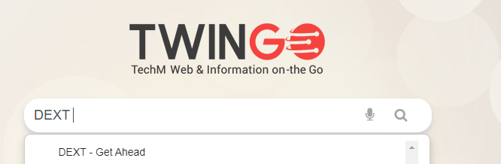

1. **Click on DEXT Link. DEXT Page will be launched.**

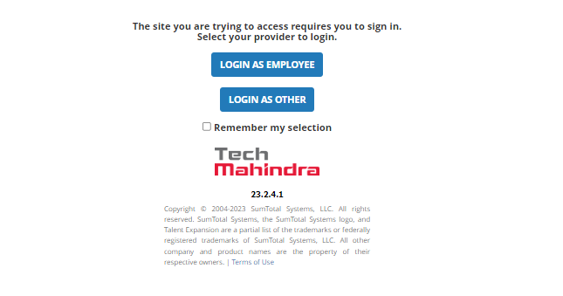

1. **Click on Login As Employee.**

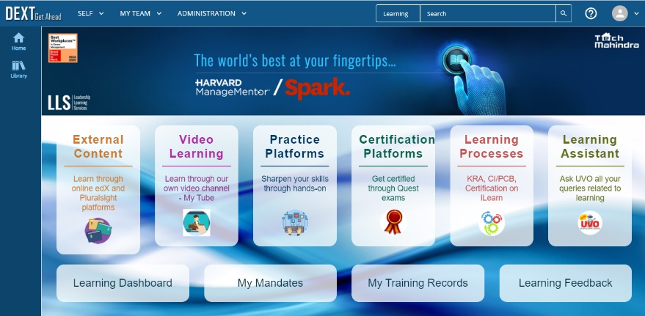

1. **On DEXT Page, click on My Mandates**

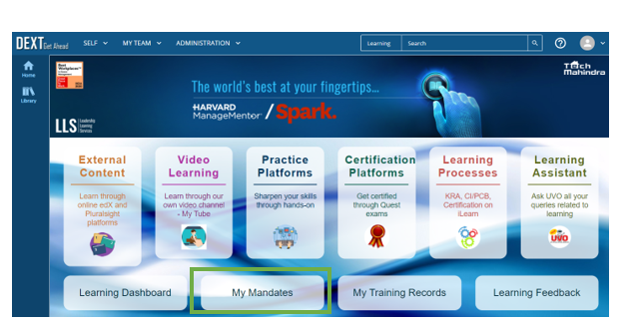

1. **Enter Course Id and Click on Search Button**

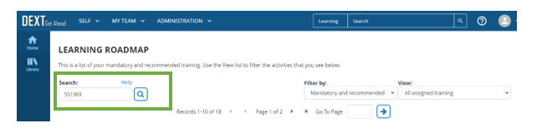

1. **Click on Start Button to launch the course.**

## Direct Search on DEXT Homepage

1. User can directly search for the course id on DEXT Home Page
2. Path: Twingo->DEXT->My Mandates or Search for the course id.



1. Enter Course Id and Click on Search

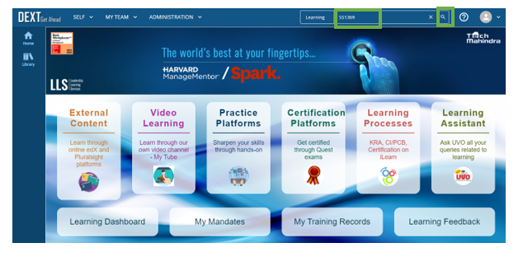

1. Click on the course id to launch the course

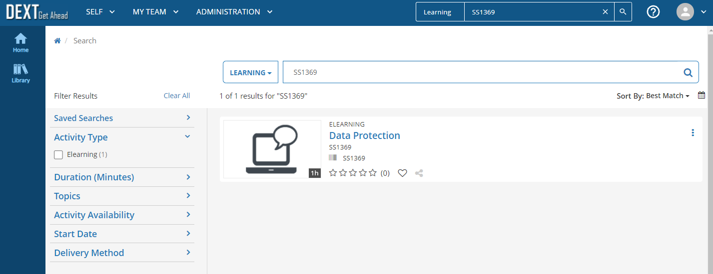

1. Click on Start Button to Launch the course

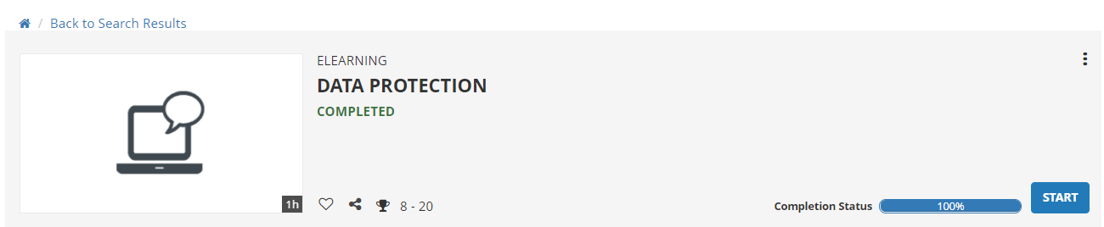

**Please ensure pop-up blocker is disabled on the browser.**

# i am unable to launch the course or course is freezing and i am unable to proceed further. what should i do?

Ans:

1. Use Chrome browser to access DEXT.
2. Clear cache, cookies or reset the browser before attempting the course.

* On your computer, open Chrome.
* At the top right, click More.
* Click More tools. Clear browsing data.
* At the top, choose a time range. To delete everything, select All time.
* Next to "Cookies and other site data" and "Cached images and files," check the boxes.
* Click Clear data.

1. If the problem persists even after following the above steps, try in incognito mode.

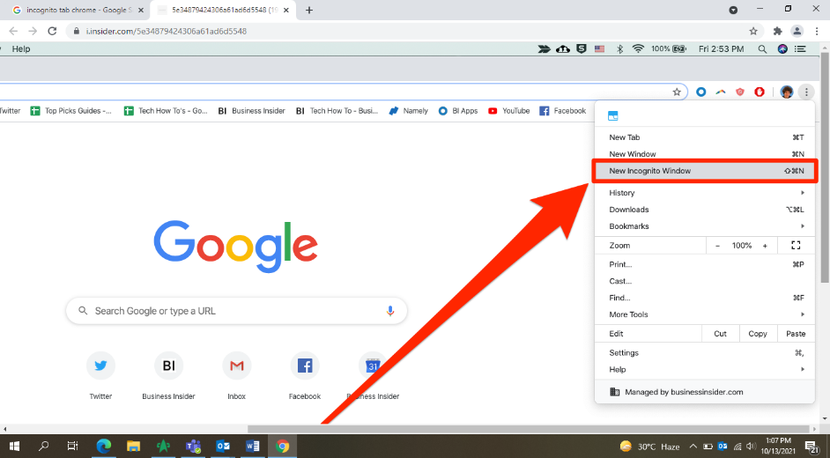

1. If the issue persists, restart your system and try to access the course
2. Try launching course on phone. Steps are provided in the question below.
3. If the issue persists, reach out to the local TIM Team as they can help you access the activity. TIM could check system/browser issue.

# How can i launch course on my phone?

1. Download “**SumTotal Mobile**” app on mobile from Play Store/App Store
2. Enter the following url:  <https://techmahindra.sumtotal.host/core/> and click on Next Button.

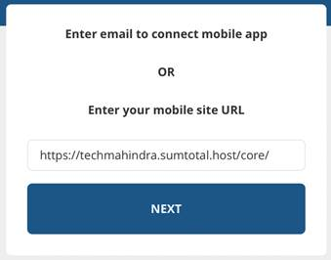

1. Click on Login as Employee

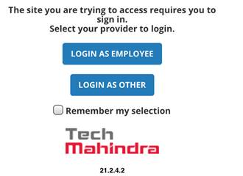

1. Enter TechM Credentials and click on Sign In button

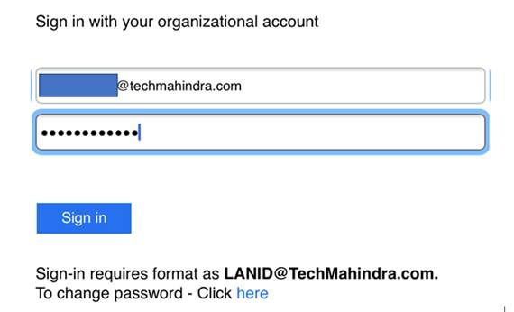

1. Click on Search Icon at top-right

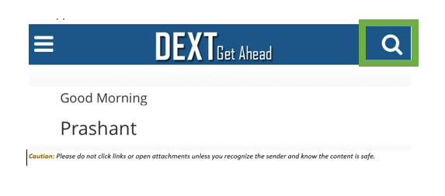

1. Select Learning (It should be selected by default) and enter Course Id

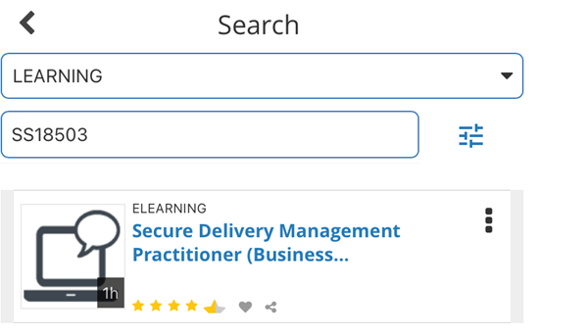

1. Click on Start

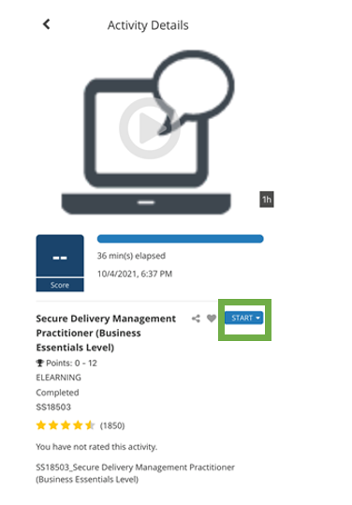

1. Click on Start Online

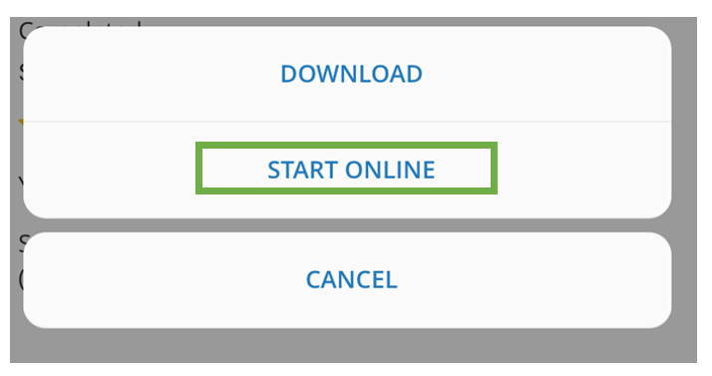

1. After completing the course, click on close icon

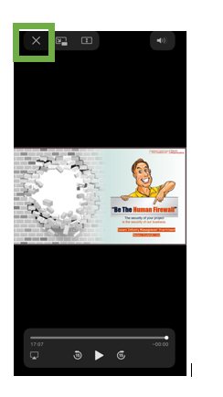

# How can i assign the course to the associates who report to me?

Twingo > DEXT- Get Ahead > My Team > Manager Dashboard on DEXT

# HOW CAN I DOWNLOAD COURSE COMPLETION CERTIFICATE?

The training completion certificate are available in ‘My Training Records’ as well as clicking on ‘Attempt History’ on DEXT platform.

Path: Twingo > DEXT- Get Ahead > My Training Records

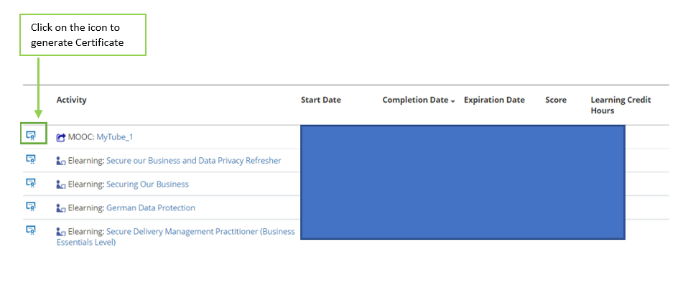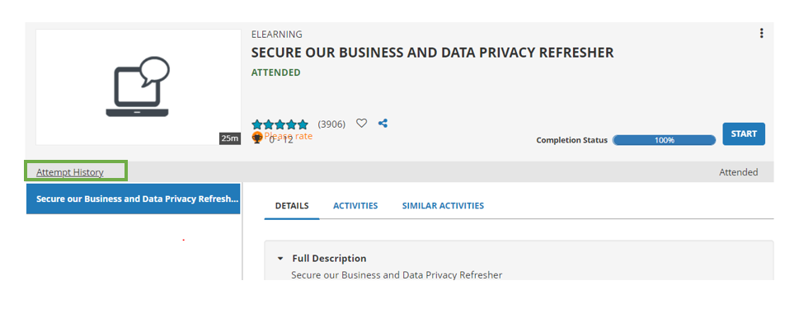

# hOW DO I GET COMPLETION STATUS FOR MY TEAM?

Twingo > DEXT- Get Ahead > My Team > Manager Dashboard on DEXT

# WHAT IS THE EMAIL DL FOR RAISING ISG SECURITY MANDATE QUERIES?

ISG Security Awareness Team can be contacted at sec.awareness@techmahindra.com

# WHO SHOULD I CONTACT IF I HAVE ANY QUESTIONS ABOUT THE ISG INFORMATION SECURITY TRAINING COURSE?

ISG Security Awareness Team can be contacted at sec.awareness@techmahindra.com

# WHAT IS THE FREQUENCY OF SECURITY AWARENESS TRAINING COURSES?

**Following courses are one-time**

* SS1369 – Data Protection
* SS18449 – Securing Our Business
* SS18503 - Secure Delivery Management Practitioner
* SS18220 - BPO Domestic Awareness
* SS1431 - How to build secure applications using TechM’ s Standard, Tools and Guidelines.

**Refresher Course**

* SS18668 - Secure our Business and Data Privacy
* This course is re-assigned every year to all the associates